Software Design Specification Template
Software Design Specification for UNISKILL based on event driven (function oriented) technology
Table of Contents
1. Introduction
1.1 Purpose
1.2 Document Conventions
1.3 Intended Audience and Reading Suggestions
1.4 References

Analysis Model
  - Methodology Used (If Structural)
  - Use Case diagram (Also include use case specifications)
  - ER Model
  - Data Flow Diagram ( Also write Process Specifications)
  - Control Flow Diagram (Also write Control Specifications)
  - State Transition Diagram

Design Model
  - Architectural Design
    - System Architecture Diagram
    - Description of Architectural Design
  - Database Design
    - Data Dictionary
    - Normalization
  - Component Design
    - Flow Chart
  - Interface Design
    - Screenshots

Appendix B1 : Glossary
Appendix B2 : To Be Determined List

Introduction

1.1 Purpose
This SDS documents the event-driven and function-oriented design of UniSkill, a student skill exchange platform that combines onboarding, marketplace discovery, service listing, session booking, credit transfer, and realtime room support inside one campus-oriented workflow.

1.2 Document Conventions
This document uses numbered analysis and design sections aligned with the supplied SDS template. Figures are labeled in the order they appear, tables summarize structured entities or rules, and narrative descriptions focus on observable implementation behavior from the current UniSkill repository.

1.3 Intended Audience and Reading Suggestions
The SDS is intended for faculty evaluators, student developers, testers, and future maintainers. Readers should begin with the introduction, review the analysis diagrams to understand system behavior, and then move into the design model for implementation-level structure.

1.4 References

Internal references: UniSkill frontend, backend, and Supabase migration files
Express.js Documentation: https://expressjs.com
Supabase Documentation: https://supabase.com/docs
React Documentation: https://react.dev
Next.js Documentation: https://nextjs.org/docs
2. Analysis Model
2.1 Methodology used
Development is iterative: the frontend presents the interaction surface, app routes or backend routes validate requests, and Supabase-backed tables and policies preserve consistency. This makes the platform suitable for academic explanation because each business event can be traced to a concrete interface, route, and storage effect.
UniSkill follows a function-oriented, event-driven design approach. Important user events such as signup, OTP verification, marketplace search, booking, wallet settlement, review submission, and room entry trigger discrete backend flows that update persistent state and communicate changes back to the UI.
2.2 Use Case diagram
Use Case Specification
Name Of Use Case
Actor
Pre Condition
Primary Flow of Events
Alternate Folw Of Events | Alternate Flow 1…..
 | Alternate Flow 2…..
Post Condition
Use Case termination

Representative use case specification: Book Session. Precondition: learner is authenticated and a mentor or service listing is visible. Main flow: learner selects a listing, submits a booking request, the sessions API validates payload and creates a pending session, the mentor receives the pending request, and both users later access room or chat surfaces. Postcondition: a persistent session record exists with a traceable status.
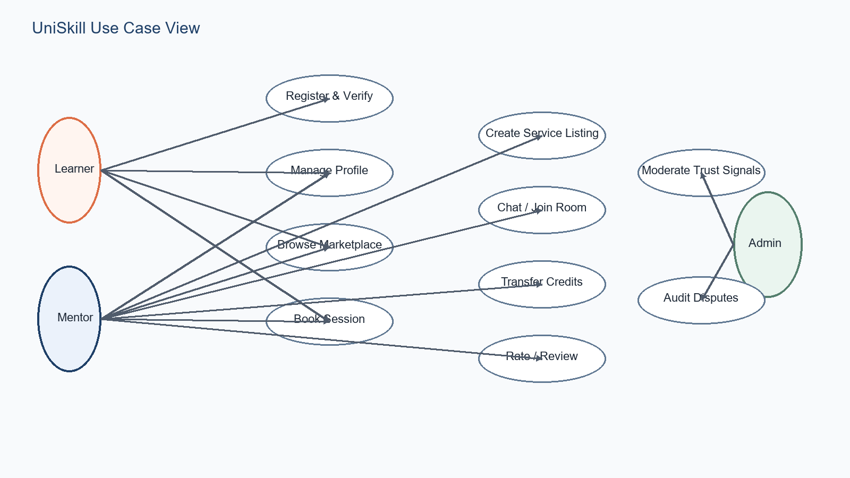
Figure: UniSkill use case view
The figure below summarizes the primary actors and their major use cases in UniSkill.
2.3 ER Model
Profiles act as the central entity. Sessions connect mentors and learners, transactions preserve wallet history, reviews capture trust signals, and messages or notifications support coordination around the learning workflow.
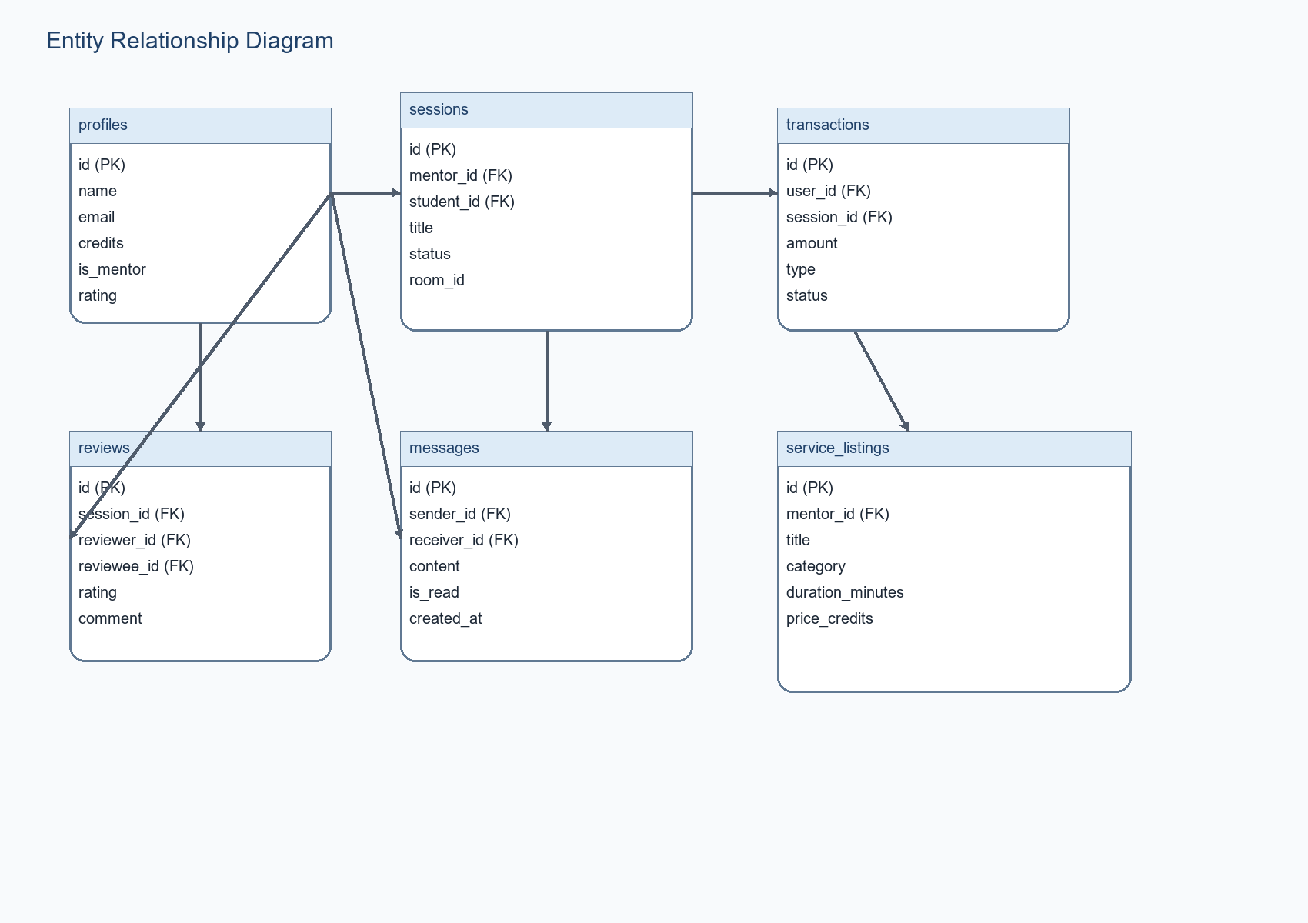
Figure: UniSkill entity relationship diagram
UniSkill stores identity, booking, communication, and value exchange in a relational schema. The following ER diagram captures the core entities used by the current system.
2.4 Data flow Diagram
Process specification summary: P1 Registration and Verification validates identity details and writes profile plus vault data; P2 Session Discovery and Booking reads marketplace state and creates or updates sessions; P3 Wallet and Credit Transfer records balance-affecting events and leaves an auditable transaction trail.
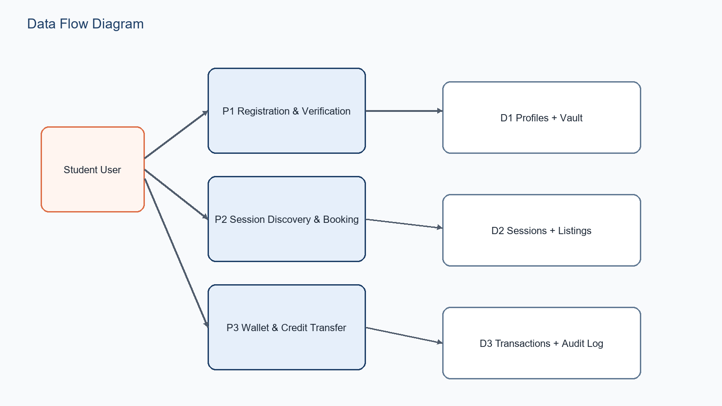
Figure: UniSkill data flow diagram
The main data-flow perspective for UniSkill is driven by student inputs entering registration, booking, and wallet processes, each of which writes to a controlled data store.
2.5 Control Flow Diagram
Control specifications: booking requests are only accepted from authenticated users; pending records prevent direct transition to completion; and credit-affecting operations must read persistent session and profile state before confirming balance updates.
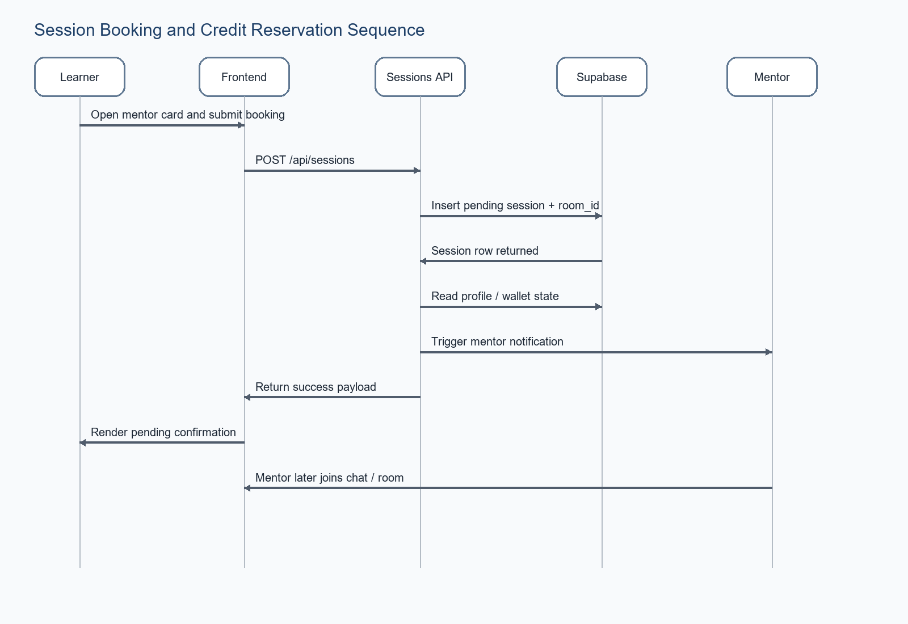
Figure: Session booking and control progression
Control flow in UniSkill emphasizes decision points around booking validity, session state transitions, and wallet mutation safety. The control diagram below focuses on the booking-to-settlement path.
2.6 State Transition Diagram
The important transitions are pending to confirmed, confirmed to in-progress, and in-progress to completed. Cancellation and dispute states branch from mid-lifecycle checkpoints so that the system can preserve recovery and moderation logic.
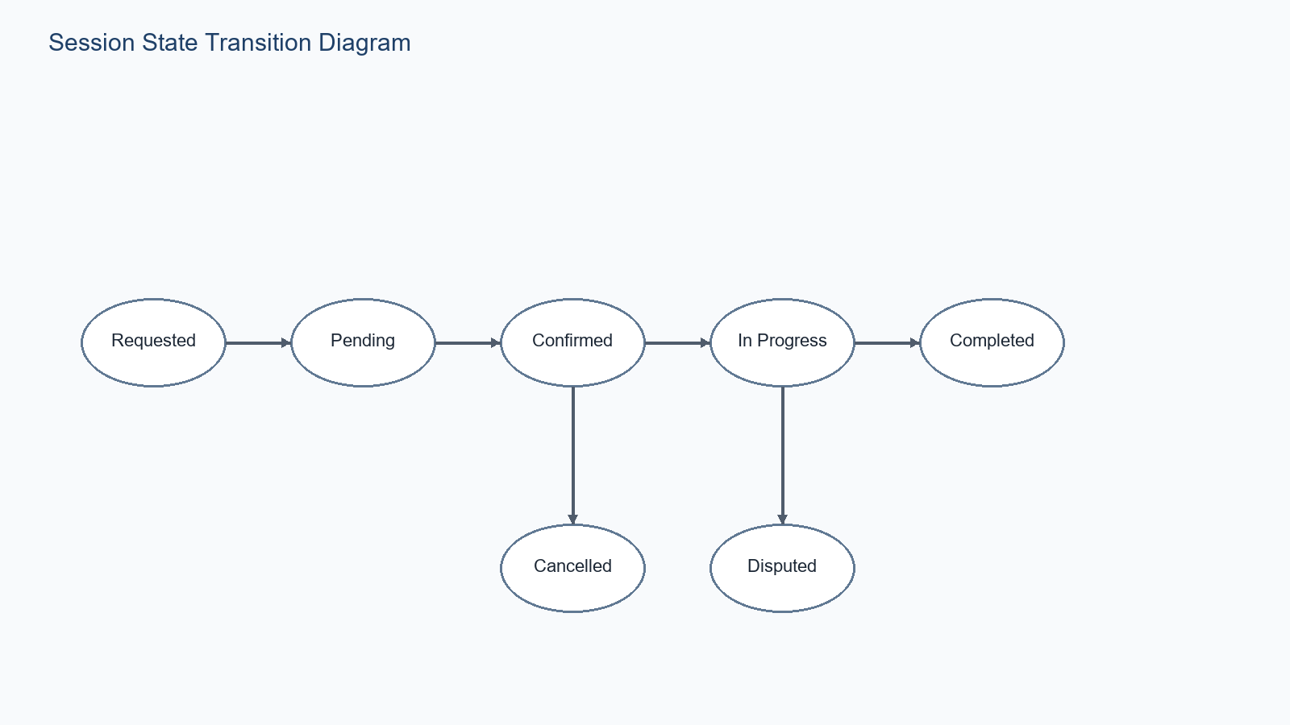
Figure: UniSkill session state transition diagram
UniSkill models the session lifecycle explicitly so the interface, notifications, and audit behavior remain consistent across learners and mentors.
3. Design Model
3.1 Architectural Design
3.1.1 System Architectural Diagram
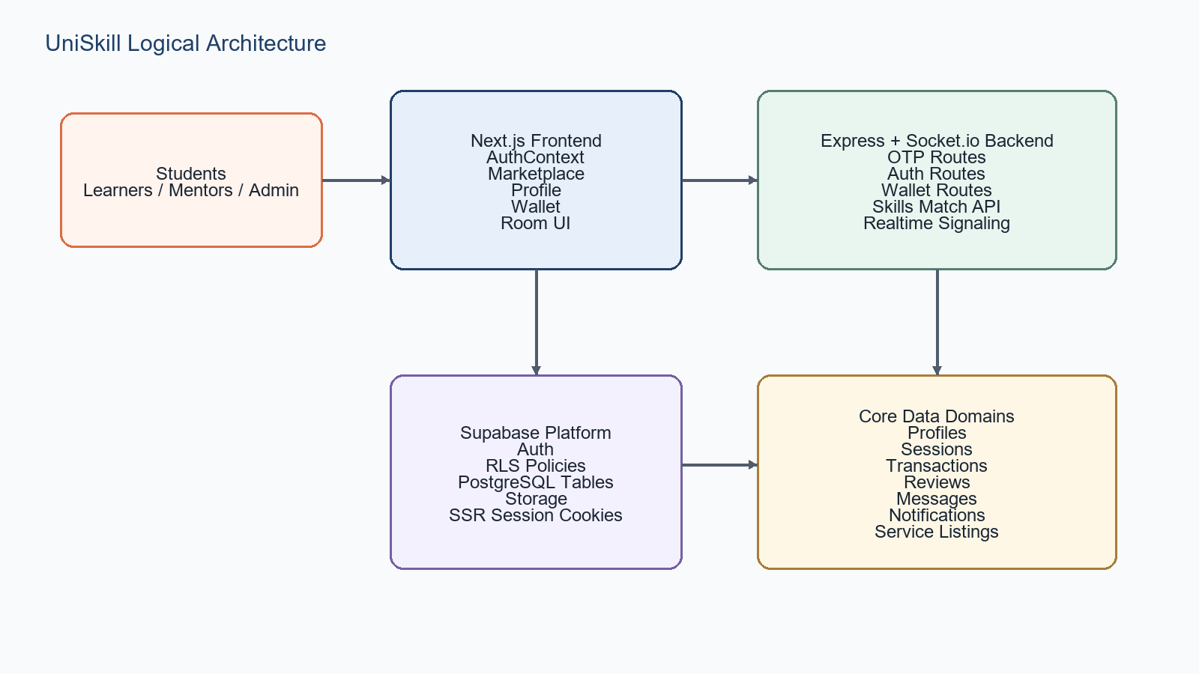
Figure: UniSkill architectural design
3.1.2 Description of Architectural Diagram
This separation keeps public browsing, protected identity, business workflows, and persistence concerns distinct while still supporting a smooth campus-user experience.
UniSkill is organized as a layered web system. Students interact with the Next.js frontend, which exposes onboarding, profile, explore, wallet, dashboard, and room surfaces. Business actions reach app routes or the Express plus Socket.io backend, where validation, OTP logic, sessions logic, wallet rules, and realtime signaling are applied. Supabase supplies authentication, relational storage, row-level security, storage, and protected session state.
3.2 Database Design
3.2.1 Data Dictionary
- Name- the primary name of data and control item, the data store or an external entity.
- Alias- other names used for the first entry.
- Where used / how used – a listing of processes that uses the data or control item and how it is used.
- Content description – a notation for representing content.
- Supplementary information – other information about data types, preset values, restriction or limitations, etc.>

Data Store / Field Group | Meaning | Used By
profiles | Public user identity, display, wallet snapshot, verification flags | Signup, profile, dashboard, wallet, reviews
user_verification_vault | Sensitive institutional identity details | OTP verification and private trust checks
sessions | Booked learning interaction with lifecycle status | Explore, sessions API, dashboard, room
transactions | Wallet movement and settlement history | Wallet page, backend validation, audit review
service_listings | Mentor offer with title, category, duration and credit price | Explore and mentor listing flows
messages / notifications | Coordination and event awareness records | Room, chat, dashboard and follow-up flows

The table below summarizes the most important data structures used by UniSkill.
3.2.1 Normalization
Apply the normalization process on the tables of your database and also explain the normal form that has been applied on the database.
In practical terms the design aligns with first normal form through atomic columns, second normal form through dedicated key-based tables, and third normal form by separating non-key attributes such as reviews, notifications, and messages into their own relations.
The UniSkill schema is normalized to reduce duplication across public identity, private verification, booking, and transaction concerns. Profile data is separated from the verification vault so sensitive identity details do not need to be repeated on public surfaces. Sessions and transactions are stored in dedicated tables rather than embedded inside profiles, which prevents update anomalies and supports auditable historical records.
3.3 Component Design
3.3.1 Flowchart
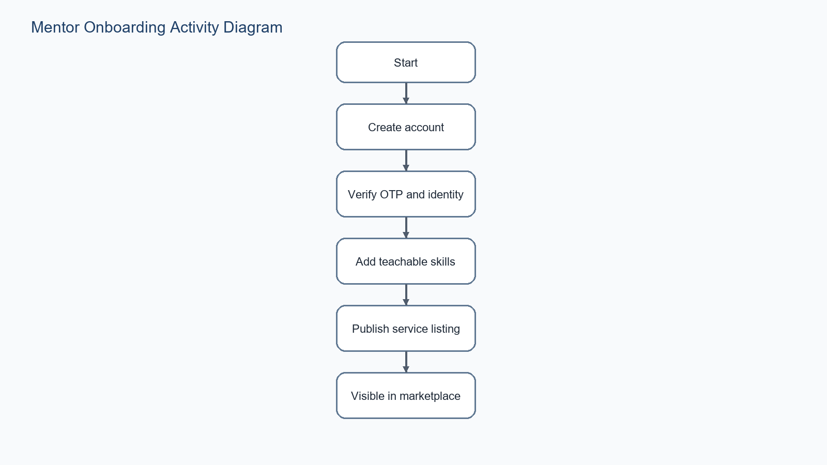
Figure: Mentor onboarding flowchart
The following flowchart illustrates a typical mentor onboarding path from account creation to marketplace visibility.
3.4 Interface Design
3.4.1 Screen Shots
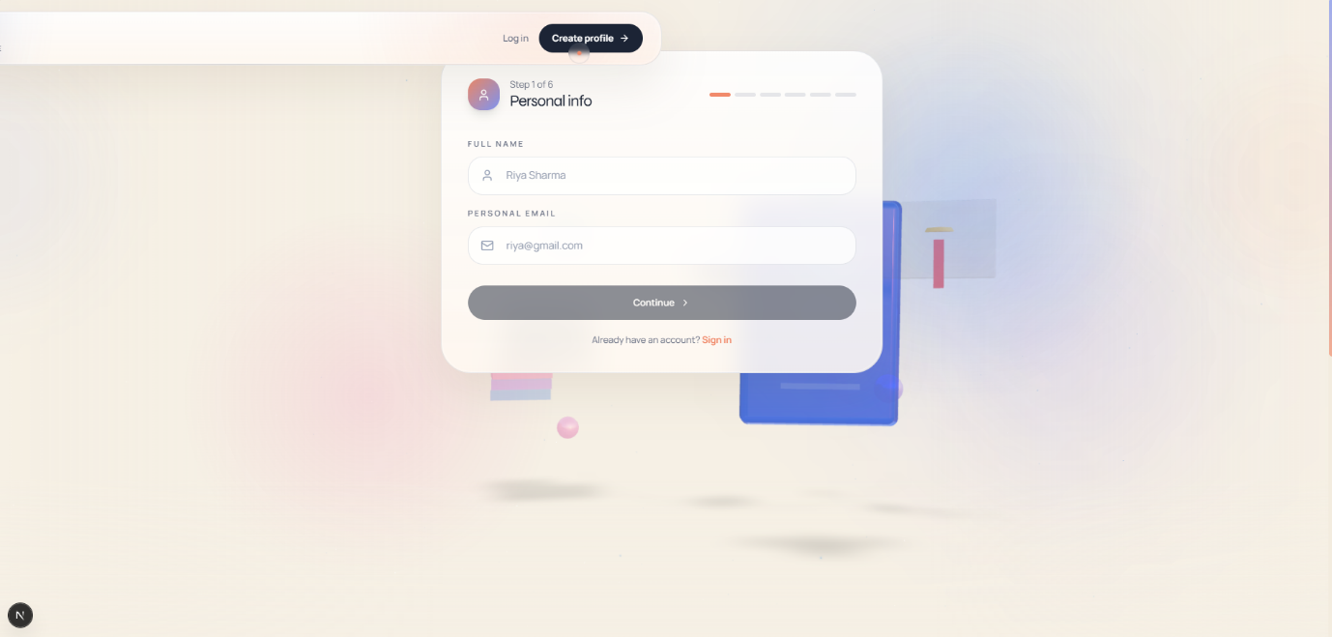
Screenshot: UniSkill signup flow
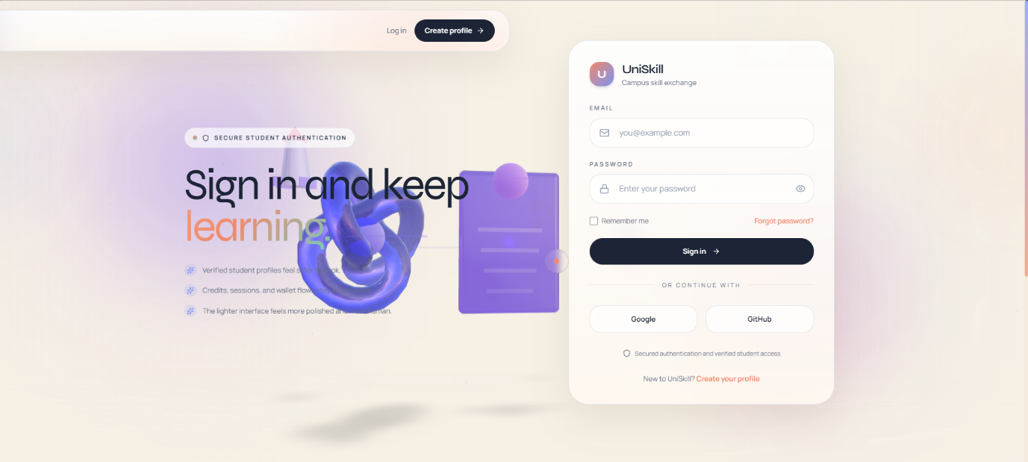
Screenshot: UniSkill login page
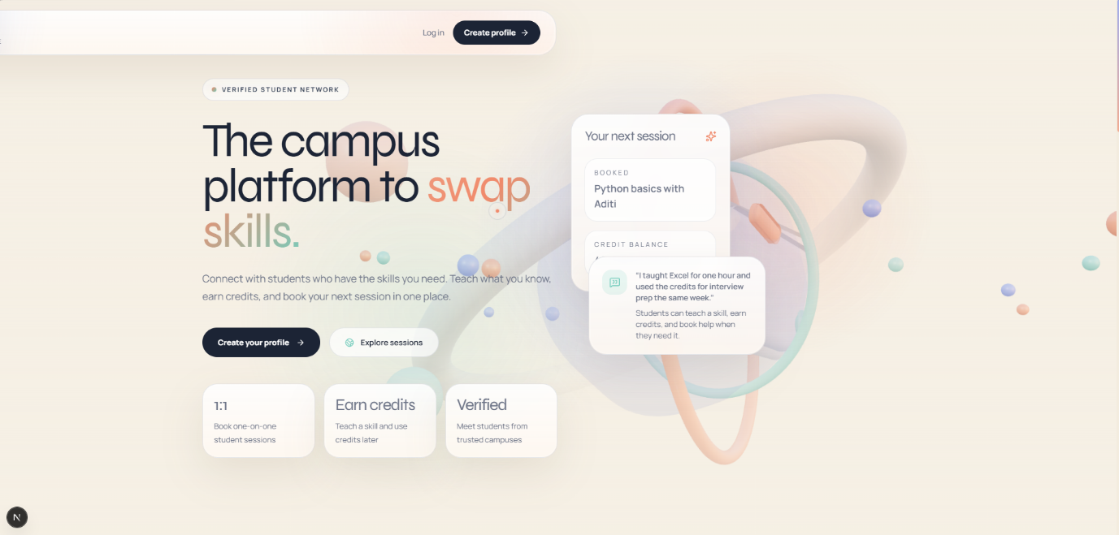
Screenshot: UniSkill landing page
Screenshots from the running UniSkill frontend are included below to show the current interface treatment for public and onboarding flows.
Appendix B1: Glossary
Credits: internal value units tracked through the wallet and transactions tables.
Session: structured learning interaction with a persisted lifecycle state.
Verification vault: private data store for sensitive institutional identity attributes.
Service listing: mentor-authored marketplace offer used for discovery and booking.
Mentor: student offering a skill, session, or service listing.
Learner: student seeking help or guidance from a campus peer.
Appendix B2: To Be Determined List
TBD-3: Whether additional admin moderation screens will be completed in the same academic release.
TBD-2: Final production deployment domain and infrastructure owner.
TBD-1: Final names and roll numbers of the submitting student team.

